Good Practice Story

Case Conferencing: Effective Method to address Child Trafficking and Sexual Exploitation in communities

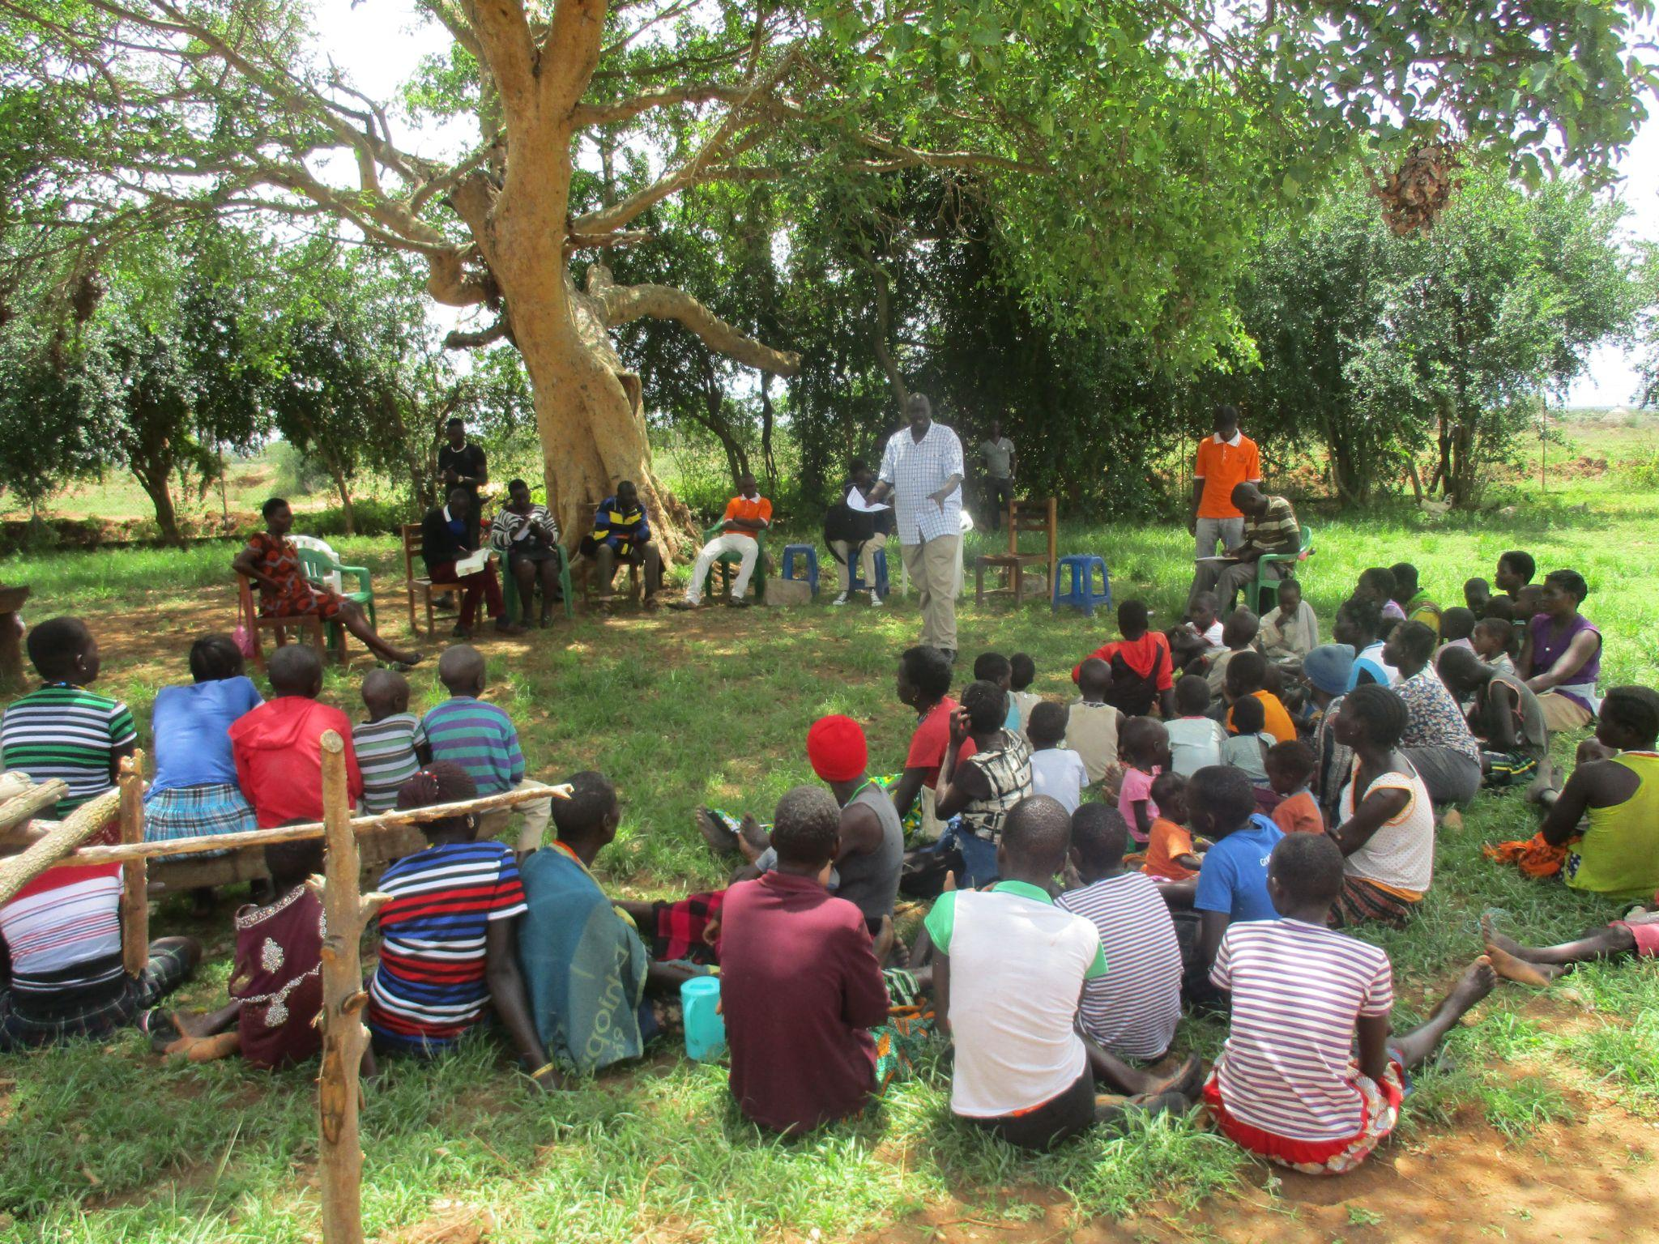

The majority of community members in Uganda conceal child rights violations and resort to amicable resolution of such cases between the parties involved, not always with a child-centered protection approach in mind. This practice contributes to normalise and prepetuate cases of child trafficking and sexual exploitation of children specifically in the Karamojong community. With this in mind, government officials, like-minded child protection organisations, community members and survivors were brought together for a case conference to discuss Child Trafficking and Sexual Exploitation (CT & SEC) cases that happen within the community.

Unreported cases
Culturally, the Karamojong people have been silent about cases of abuse, especially sexual abuse in the community. According to their culture, a girl who has been defiled is supposed to get married to the perpetrator leading to early child marriage. As a result of this, many cases of child abuse go unreported because parents still fear to report and would rather resolve them with the perpetrators. From knowledge gathered from community dialogues, it was noted that some caregivers are contributing greatly to Child Trafficking and Sexual Exploitation (CT & SEC) and actually might be heavily benefiting from it.

Stakeholders involvement

Through the case conference meetings held between 28 April 2021-1 May 2021, community members opened up about the cases they face in the presence of their local leaders. The goal of the case conference meetings was to develop a community-concerted strategy with all stakeholders who provide a protective shield for the survivors aimed at responding to cases that have been hidden or ended prematurely without hearing or follow up in order to offer appropriate support to survivors of Child Trafficking & Sexual Exploitation of Children.

These meetings took place in Lorengecora, Lokopo, Matany and Lopeei Sub Counties in Uganda. About 30 children(F 21, M 09) and 236 adults (69 men, 167 women) participated in the four-day conference meetings. Other notable stakeholders who had a role to play in the discussions included the District Probation and Social welfare officer, the District Child and Family Protection Unit, Community Development Officers, Local Council 1, Parish Chiefs, Sub County Child and Family Units, teachers and community members including caregivers, survivors and persons with disabilities.

The reality
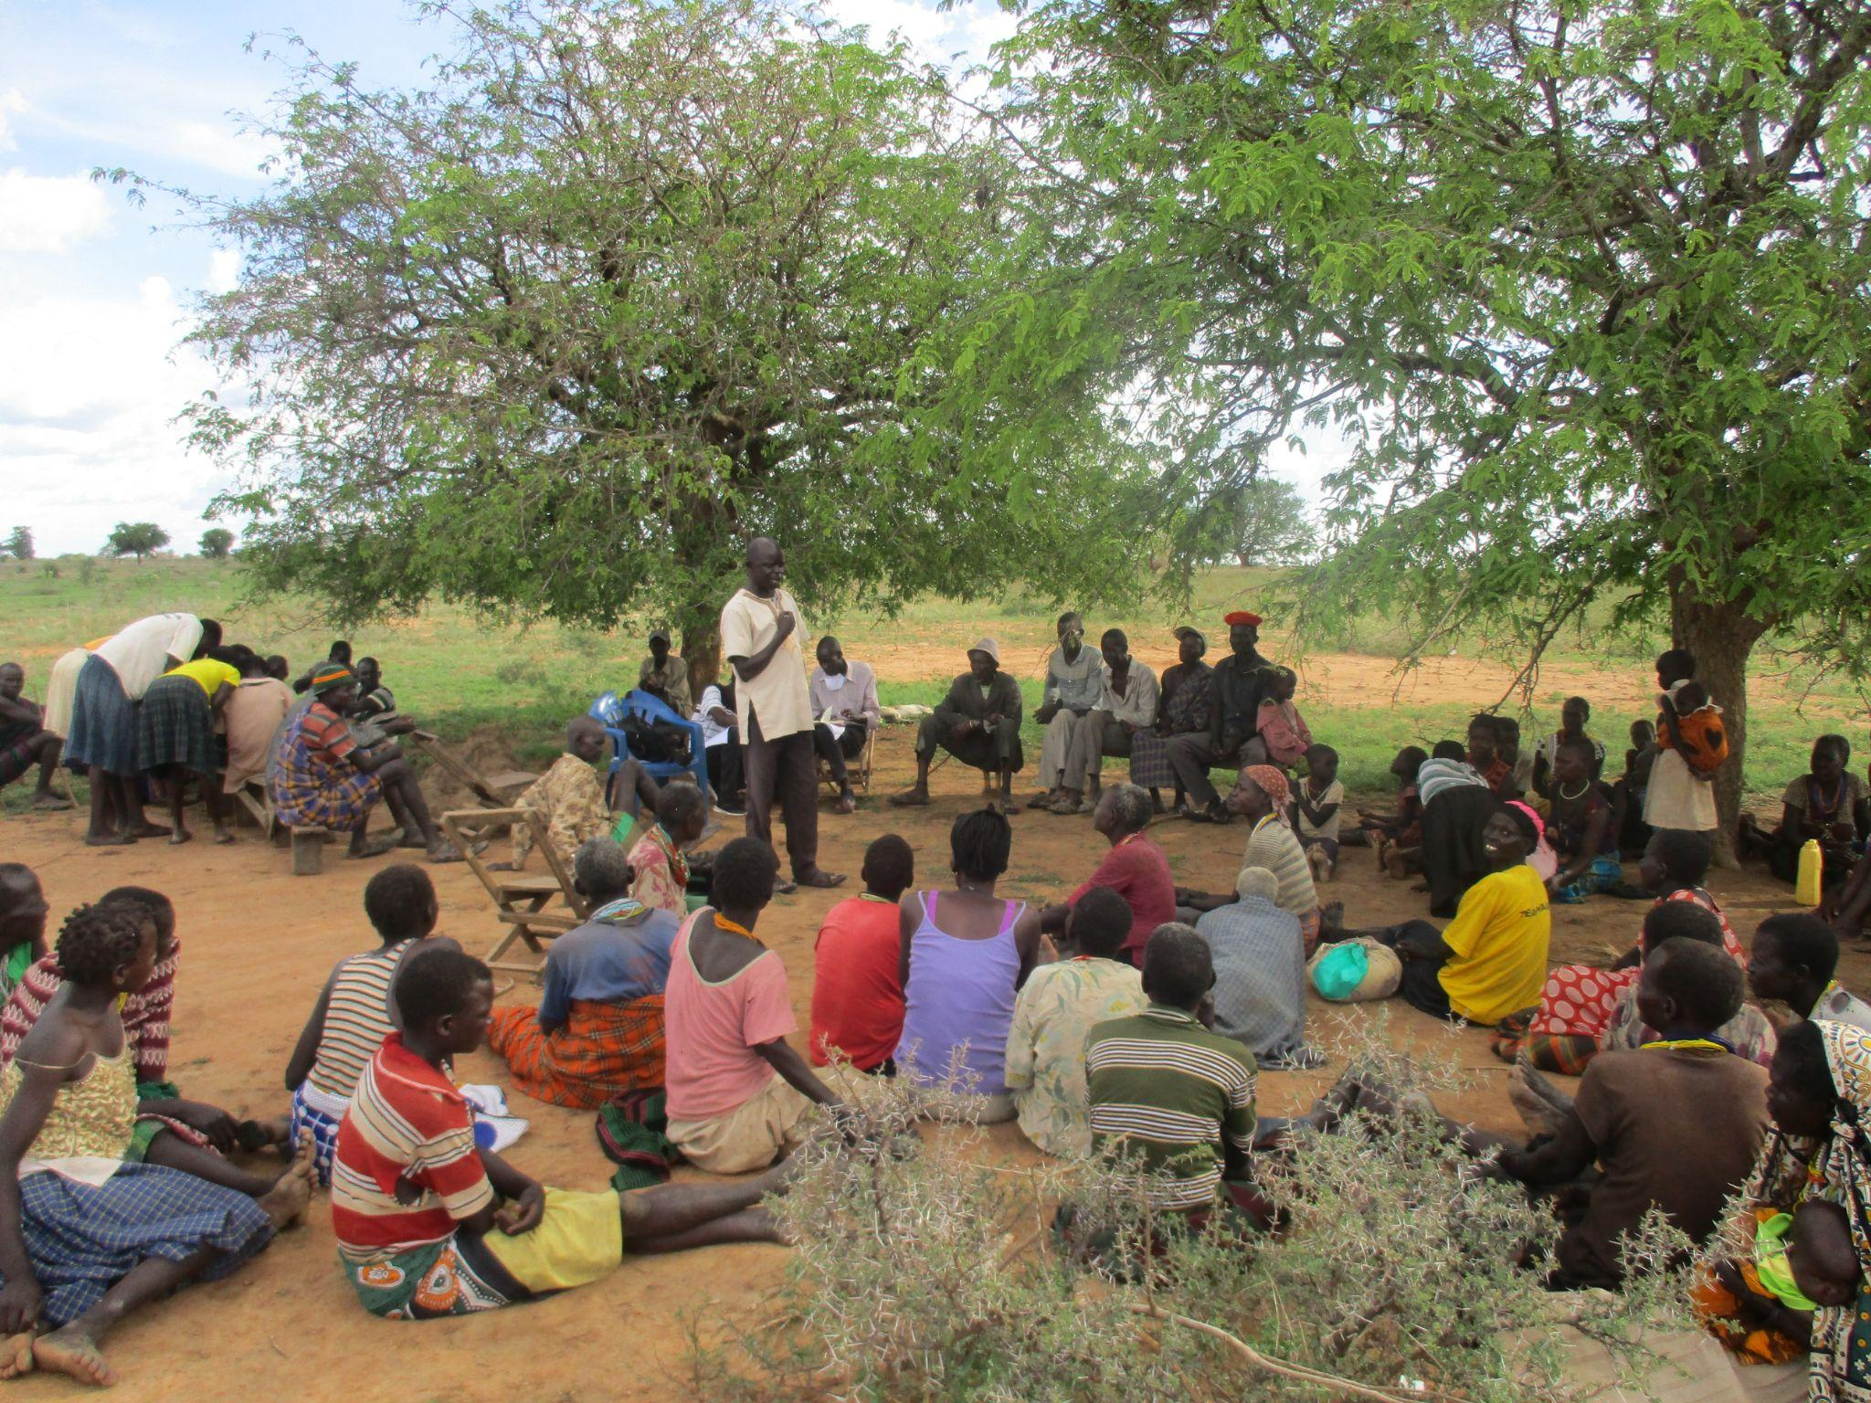
The meeting provided a forum for voluntary sharing of experiences of survivors and how the system has handled their cases. It also provided a platform for learning and linking the survivors to appropriate services, and offered a protective shield for sustainable reintegration. As much as sharing experiences was voluntary, survivors had a case worker present, at each case conference meeting to offer support in case any of them broke down, each of these survivors were linked to the a child protection champion in their respective villages, who works closely with the Project staff to ensure further support for the survivors even after the conference.

The Community Development Officers (CDOs) of the four sub-counties committed to following up the cases of lost children in their sub-counties. One of the discussions was on the temporal school dropout situation that has gone on for years in Karamoja and how this has made children more vulnerable. Students miss two terms and show up for the third one which they consider to be important as it promotes them to the next class. As they miss two school terms, children migrate to business areas like Teso, Kenya, Busia, Mbale, Kampala to make ends meet and support their families, a trend that parents, children and youth have normalised.

The Community Liaisons Officer engaged the participants in a discussion about child trafficking and sexual exploitation of children and the role of the community in curbing it. Participants were educated on the push factors that see many fall victims of CT & SEC such as domestic violence, peer pressure, low levels of education, parental neglect, poverty and negative cultural norms. The Probation Officer also discussed at length the difficult life that children go through as a result of migration such as poor housing, forced begging, accidents, sexual abuse, HIV/AIDS infection, early pregnancies, child sacrifice and harvesting of organs.

Tailored solutions

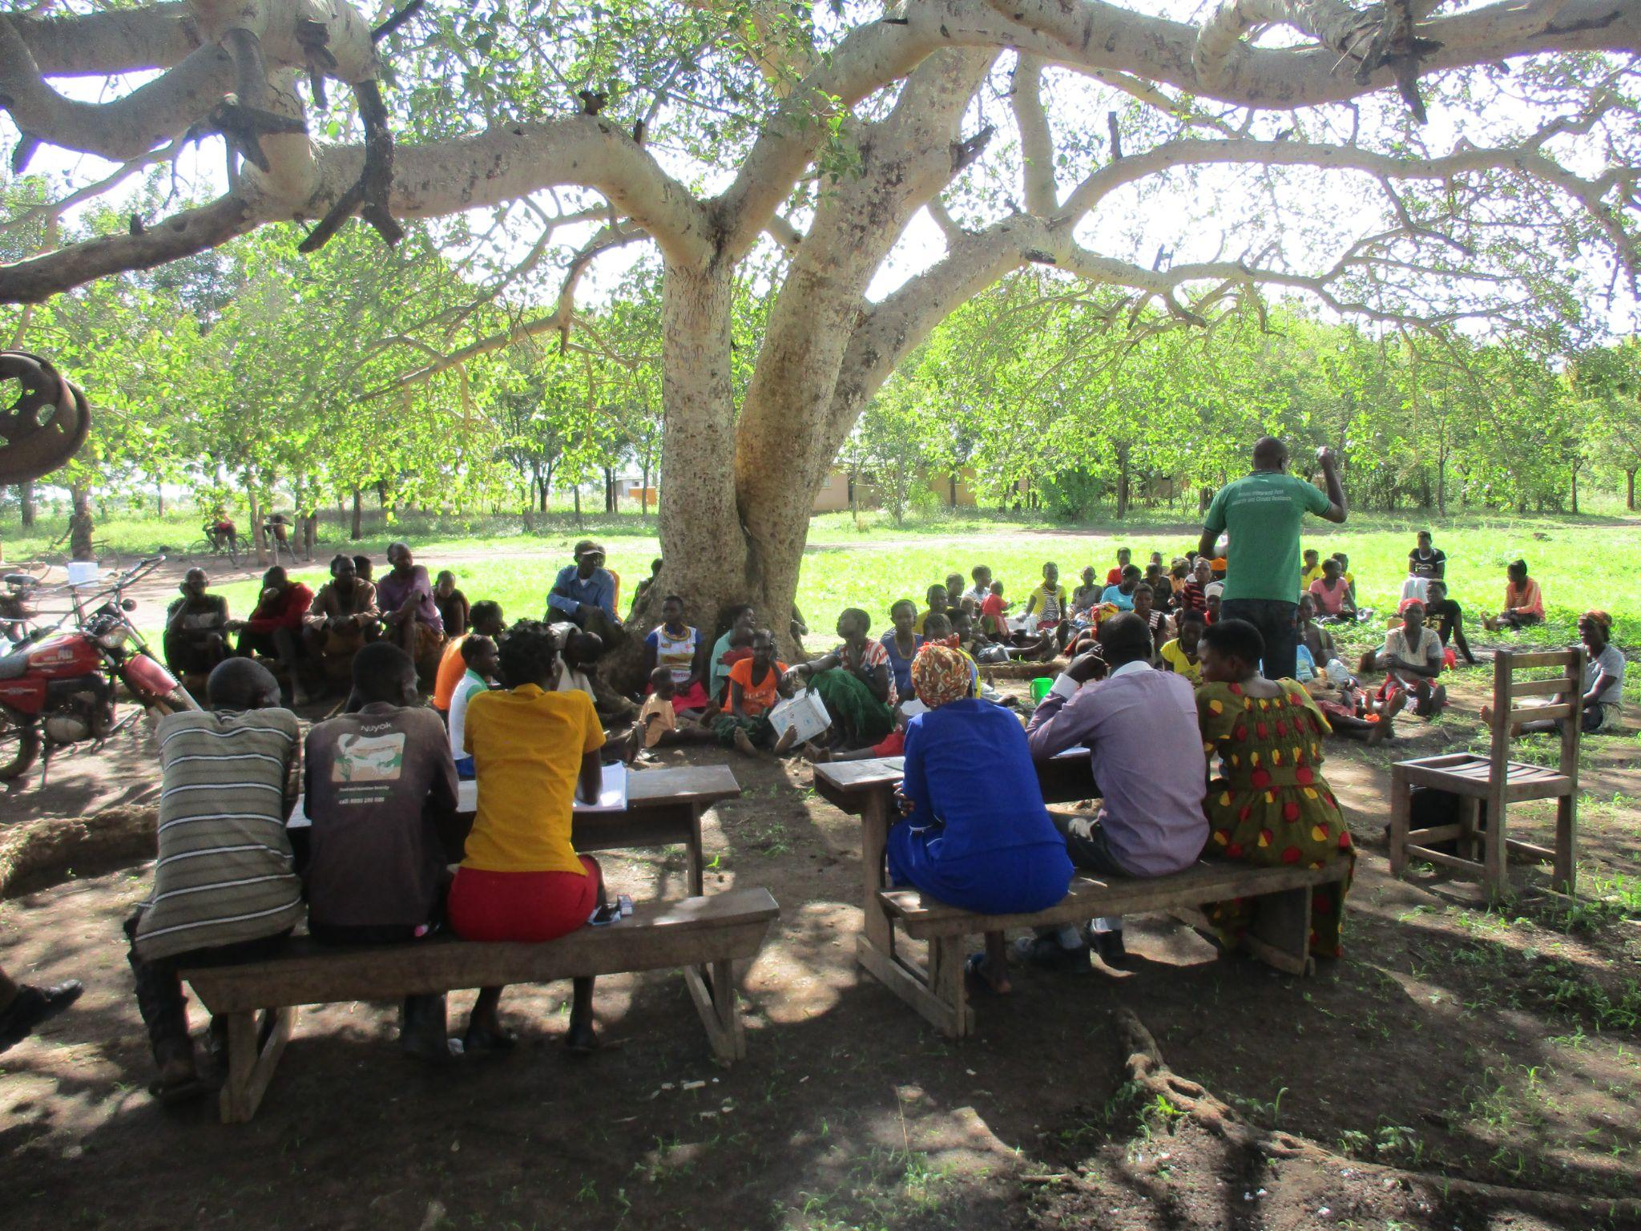
The different stakeholders discussed Child Trafficking and Sexual Exploitation (CT & SEC) cases and they identified and examined unique solutions that are tailored to individual care of the survivors. The participants were also taught how to be able to identify, register, case manage and refer different cases to ensure continuous follow up for appropriate management.

The District Child and Family Protection Unit took participants through legal procedures and processes on how to access justice regarding trafficking cases, migrations, sexual abuses, land disputes, children maintenance, child negligence, theft and other kinds of crimes common in society.

Speaking about this forum, Lopeei, a Local Council 1 chairperson said, “This should be an ongoing practice because it makes people open up about the silent cases in the community.”

Outcomes
As a result of the 4-day case conference meeting, the communities involved acquired confidence in their leaders and appreciated their commitment to resolving the community cases. This trust had been lost as many claimed to have reported cases that were never followed through.

The case conferencing sessions provided a platform to report the silent cases such as child neglect, defilement and children who were at risk of trafficking because of the need to fend for their families or look for school fees. Out of the 30 cases discussed, in all 4 sub counties, 24 cases were resolved during the conferences, the 6 which were not resolved were for lost children. A recommendation to register children in the villages by LC1s was shared by the participants. These children were identified as survivors of Child Trafficking and 10 of these cases were recommended for vocational training. This method brought better solutions than others because it involved child protection organizations and district stakeholders who discussed and made immediate decisions, giving immediate and timely solutions.

One case of sexual abuse and exploitation was followed up by the Child and Family Units, and the perpetrator was brought to book. Additionally, five cases of children (4 girls and 1 boy) who were on the verge of being trafficked were identified, and referred to Child Protection Champions for psychosocial support and they were also prepared for enrollment in school.

Two persons with disabilities requested community members to refer children with disabilities to the Probation Officer, who would help them benefit from the government opportunities in order to reduce their risk of vulnerability to trafficking and sexual exploitation.

A rehabilitation centre was recommended by the Probation Officer to train survivors who were identified for skilling during the conference sessions. The officer went ahead to contact the principal at the centre who agreed to have three girls enrolled under government sponsorship to acquire skills training to help them in future.

The community members in the four sub-counties were made aware about the Karamojong children who were stuck in Kenya and were willing to return but had no means of coming back home. This was taken seriously and it fueled the commitment to work in a collective effort with other organisations and the government of Uganda and Kenya to bring back the girls. 32 girls and 3 babies were returned home on 5 August 2021 and successfully reintegrated.

Tackling Child Trafficking and Sexual Exploitation of Children
The case conference activity is part of the Community Action Project to end Child Trafficking and Sexual Exploitation of children in Napak project implemented by Dwelling Places and Terre des Hommes Netherlands and funded by the Global Fund to End Modern Slavery. It is currently being executed in the 4 sub-counties (Lorengecora, Lokopo, Matany and Lopeei).

Dwelling Places and Terre des Hommes Netherlands conveyed the District Officials, partners and community participants in the four sub-counties for the case conferencing meetings. The team also mobilised the participants to take part in fruitful discussions during the meetings. Among the 10 cases recommended for vocational skilling, 3 are being supported under the project to attain necessary vocational skills to help them in future.

The case conference method proved to have a positive impact on how the community perceive and handle cases of CT&SEC. With a victim-centered approach, collaborative efforts in case management and decision making, CT&SEC cases were unveiled and appropriate support given to those affected. It was also a good way to promote behaviour change. The case conference method is easily replicable and scalable to ensure positive change in other communities too.

